*'''  
Using PIP command install flask < 2.0 into your system  
'''*

# Step01: To check current version of flask:  
pip show flask

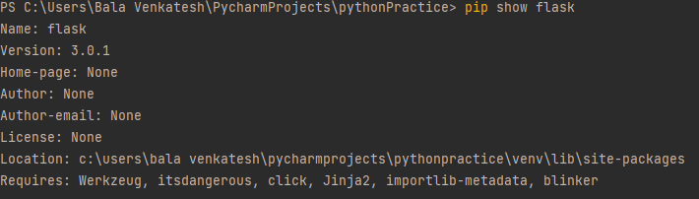

#Step02:To install required version:  
pip install Flask==1.1.2

